EDUCAUSE Sprint 2013 | Beyond MOOCs: Is IT Creating a New, Connected Age?
How Technology Can Change Pedagogy
July 31, 2013

Hank Lucas
response
new knowledge and understanding
strategies
inspiration
knowledge, insight, trends, and best practices
Getting at the heart of how f2f teaching/learning is transformed online
strengthen my IT knowledge.
understand future directions to provide leadership
learning more about how technology is changing learning and the classroom experience
information on new technologies and ideas
trends
New Technology in use
What are the trends
strateegies
desired changes and integration trends
Finds out about the latest trends
new ideas
strategies
New instructor strategies using multimedia in online courses
Learn how I can better help students
technology tied to good pedagogy
strategies
peer strategies
Eileen 2: see how the pedagogy is changing based on the new course models
data related to what online learning is really suited for
I want to teach better
learning about anothers
Cost of producing online training vs ROI
emphasis on the how
new pedagogies
evidence based technology impact on pedagogy
Learning How To Enhance In-Classroom Activity Through Technology
insight insight
ideas / use of technologies
learn how to support teachers in MOOCS
better awareness of current educational technology
explore what others are doing with MOOCs
effective technologies to enhance student learning
new ideas
ideas
Understanding of how pedagogy is related to technology
ideas and strategies
ideas
Using tech where tech makes sense
ideas
ideas
trends
The role of video and related media
insight
lessons learned
inspiration
Insight and strategy
ideas we apply to courses right know
what works - video, chat, subgroups
better understanding
deeper experience of online conferencing
ideas
what is going on in industry (trends, models, etc); ideas & insight
ideas
technologies that are effective
strategies
ideas
Future direction
how to transition into hybrid (on-line and brick and mortar) education for selected courses
teaching and learning strategies
MOOCs impact on Liberal Arts Colleges
knowledge, best practices
forward looking best practices
challenges and opportunities in engaging in MOOCs and other online education
improving learning on campus
information to share with my peers
learning on how technology has already changed pedagogy
soft benchmarking with other schools
see what the state of the art is
how technology can be used in the classroom to improve learning and teaching
gain more knowledge and awareness
Interested in how data is being used, and how is it evaluated
new connections with insightful attendees
video strategy
Connections with resources that show non-anecdotal data that support learning enhancement via technology
how to measure success
hear some practical examples of tech transforming pedagogy
Trends in Tech to Pedogogy
tech n pedagogy what's in store
new ideas
what technology I should attempt to use next quarter, being new to this university
listening to what others have to say about this topic
strategies for using technology
inspiration
pulse of perceptions
insight
staying current
Ideas for how the library might capitalize on learning technologies to impact student learning/performance
insight of changes and how to best prepare for them
best practices with effective use of technology; not just using technology for the sake of technology
how pedagogy can change technology
how to levarage MOOCs instead of fear them
ideas

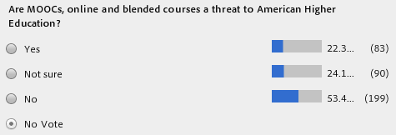
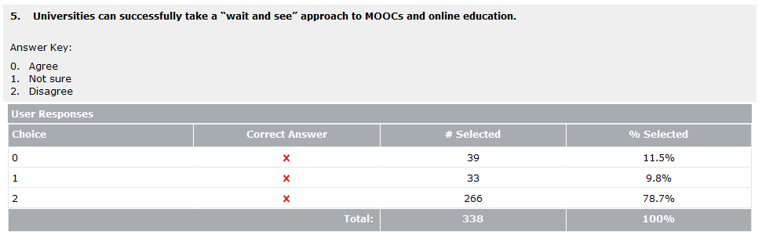

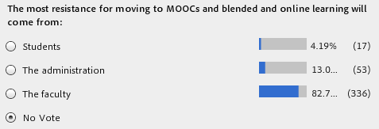

W. Eric L. Grimson
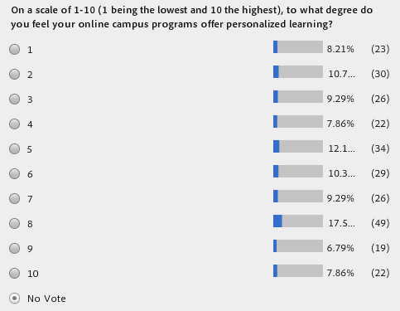
Susan Grajek
